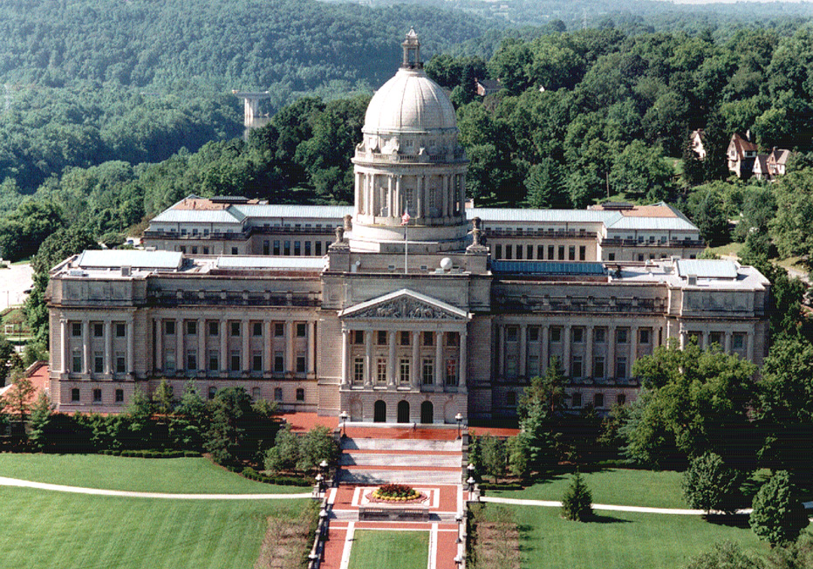
ETHICS REPORTER
March, 2017
Kentucky Legislative Ethics Commission
22 Mill Creek Park, Frankfort, Kentucky 40601-9230
Phone: (502) 573-2863
http://klec.ky.gov

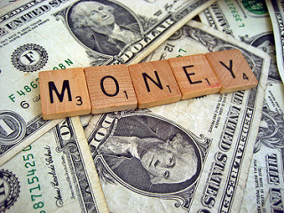
$4.6 million spent on lobbying in two months

Although the General Assembly was in session for just 20 days, $4.6 million was spent on lobbying in the first two months of the 2017 short session. Once again, the top spending lobbying organization was the Kentucky Chamber of Commerce, which spent $88,090, 19 percent more than the Chamber spent in the same period in last year’s long session. In the most recent reporting period, the Chamber reported it produced advertising in support of charter school legislation and medical review panels.

The second-leading spender is a new lobbying organization, U.S. Justice Action Network, which has spent $62,958, including $40,000 on polling. U.S. Justice Action Network supports legislation to “reduce the exploding prison population and astronomical costs to taxpayers.”

Altria is the next highest spender, spending $57,386 on tobacco-related issues including a resolution urging the U.S. Food and Drug Administration to withdraw its proposed standard for a nicotine-related substance in smokeless tobacco products; followed by Marsy's Law for All which has spent $56,968, including $40,000 on advertising in support of a proposed constitutional amendment to create a crime victims' bill of rights.

Other top lobbying spenders include: Kentucky Hospital Association ($49,788); Kentucky Justice Association ($37,855); Kentucky League of Cities ($36,392); Kentucky Bankers Association ($36,160); Anthem Inc. ($34,000); Greater Louisville, Inc. ($32,029); Kentucky Medical Association ($31,058); Kentucky Retail Federation ($29,685); Norton Healthcare ($29,575); AT&T ($28,613); Humana ($26,893); Kentucky Association of Electric Cooperatives ($25,911); Kentucky Association of Health Care Facilities ($24,199); Kentucky Association of Realtors ($24,180); Home Builders Association of Kentucky ($23,937); Kentucky Pipe Trades Association ($22,216); Kentucky Farm Bureau Federation ($21,863); Kentucky Education Association ($21,732); National Heritage Academics ($21,685); Molina Healthcare ($21,600); Hewlett Packard ($20,000).
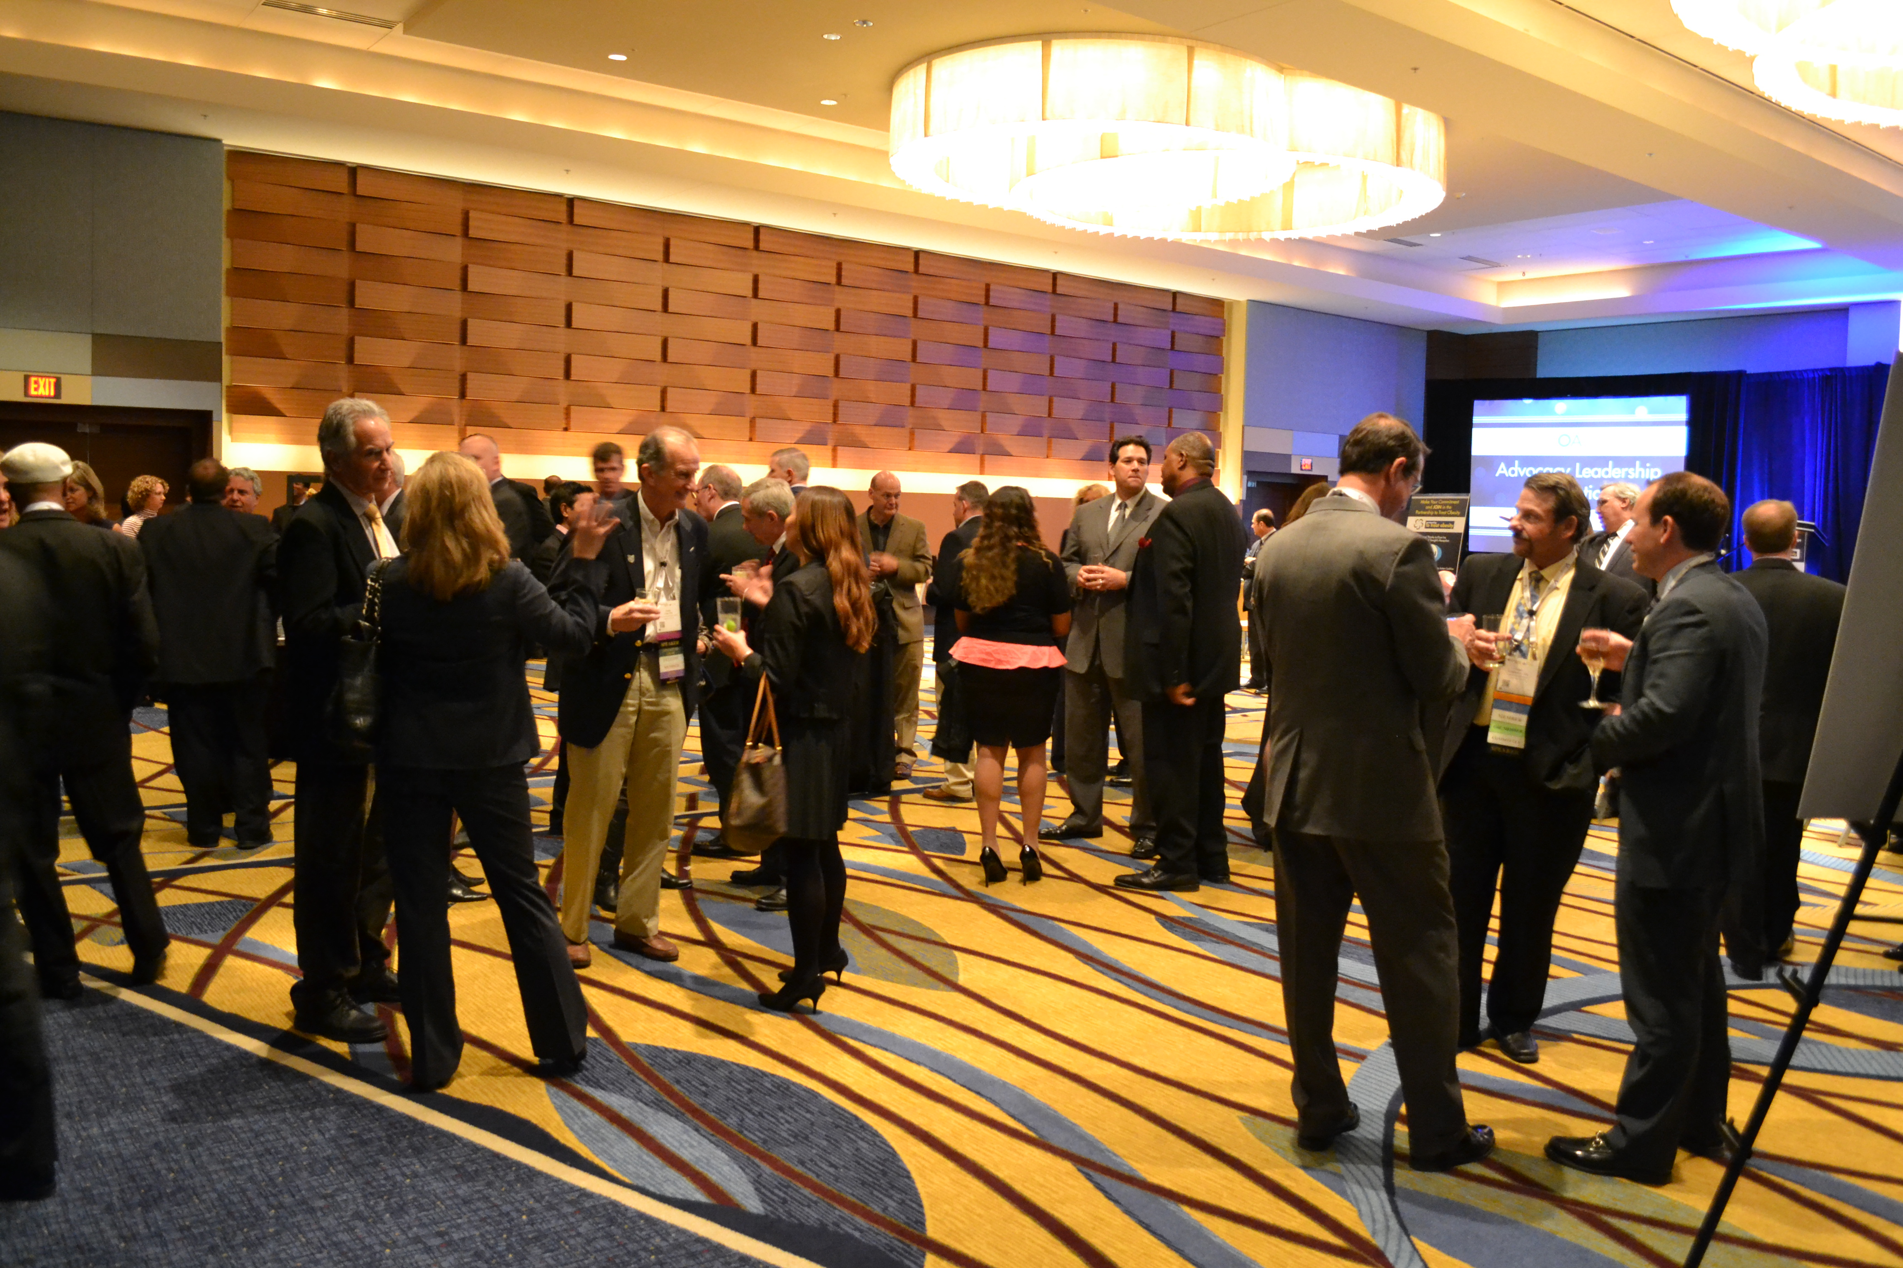
Events can be a key part of lobbying

When the General Assembly is in session, many people come to Frankfort from around the state to meet their legislators at events organized by various businesses and organizations.

In the 2017 session, the largest event was the Annual Energy Reception, held at Buffalo Trace Distillery. For that event, the Kentucky Oil & Gas Association spent $5,111, the Kentucky Coal Association spent $4,661, Duke Energy spent $250, and two lobbyists spent $450, for a total of $10, 472.

Other large events held during the 2017 session include: a Capitol Annex luncheon sponsored by the Kentucky Beverage Association ($3,849) and Kroger ($650); a breakfast at the Capitol Plaza Hotel, sponsored by Kentucky Rural Water Association ($4,268); and Louisville Night at the Kentucky History Center ($4,125), sponsored by AT&T, Beam Suntory, Charter Communications, Greater Louisville Association of Realtors, Greater Louisville, Inc., KentuckyOne Health, LG&E and KU Energy, Metropolitan Sewer District, Convention & Vistors Bureau, Regional Airport Authority, Louisville Water Company, Norton Healthcare, Sullivan University, UPS, and University Health Care.

Also, Kentucky League of Cities spent $3,450 on the City Day/City Night event at Frankfort Convention Center; Necco spent $2,534 on a Capitol Annex luncheon; Kentucky State Police Professional Association spent $2,186 on three weekly breakfasts at the Capitol Annex; Kentucky Council of Area Development Districts spent $2,120 on a breakfast at the Capitol Annex; Kentucky Cable Telecommunications Association spent $2,004 on a reception at the Capital Plaza Hotel, Kentucky Professional Firefighters spent $1,892 on a Firefighters Chili Dinner at Buffalo Trace Distillery; Kentucky Hospital Association spent $1,732 on a Capitol Annex luncheon; and Kentucky Optometric Association spent $1,579 on a Capital Annex luncheon.

AT&T spent $2,500 and Kentucky Nonprofit Network, Inc. spent $607 on an awards ceremony in the Capitol Rotunda; and Kentucky Youth Advocates spent $2,176 on a Capitol Annex breakfast.

Two lobbyists, R. Brooke Parker ($2,787) and Steve Robertson ($3,252) spent a total of $6,039 on a reception at the Hyatt Regency in Lexington.

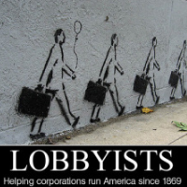
Kentucky registers a record number of lobbying interests

As the 2017 General Assembly adjourns, 722 businesses and organizations are registered to lobby. That’s a nine percent increase since this time last year.

The businesses and organizations which have registered to lobby in the past month are: Americans United for Separation of Church & State; Appalachian Citizens Law Center, Inc.; Celgene Corp.; Center for Education Reform; Kentucky Association of Home Inspection Professionals; Kentucky Solar Industries Association; Louisville Arena Authority; Mainstreet; Teamsters Local 89; Teladoc, Inc.; and U.S. Hemp Farming & Business Roundtable.

Sanitation District No. 1 and TAC Air terminated their lobbying registrations, and are no longer lobbying the General Assembly.

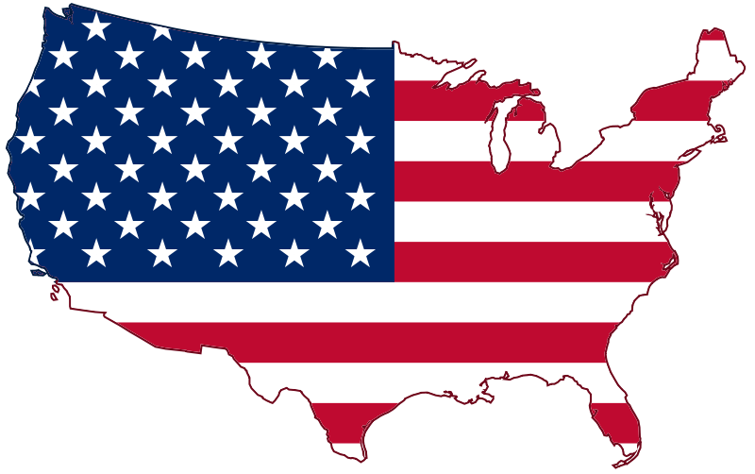
Ethics and lobbying news around the U.S.

Hunter under criminal investigation for alleged campaign finance violations
FEDERAL – Politico – by John Bresnahan – March 23, 2017

U.S. Rep. Duncan Hunter is under criminal investigation by the Justice Department over alleged campaign finance violations, the House Ethics Committee announced.

The California Congressman spent tens of thousands of dollars' worth of campaign funds on items that appear to be personal in nature during 2015 and 2016, according to records from Hunter's campaign — a potential violation of House rules and federal law.

The funds were spent on groceries and outdoor equipment, a dentist, a nail salon and a utility company, as well as on a hotel in Italy and at the Arizona Grand Resort.

Although Hunter later repaid nearly $60,000 to his campaign following news reports detailing the questionable spending, the Office of Congressional Ethics began a probe into the case. In August, OCE recommended that the Ethics Committee begin a full-scale investigation into Hunter. Only the Ethics Committee can sanction a member or staffer for rules violations.

But the Justice Department has now asked the Ethics Committee to hold off on any action against Hunter because of its own criminal probe into the lawmaker, according to a statement from Reps. Susan Brooks (Ind.) and Ted Deutch (Fla.), the chairwoman and ranking member of the panel.

Indictment charges former Sen. Jon Woods, college president, and pal in kickback scheme
ARKANSAS – Arkansas Times -- by Max Brantley – March 2, 2017

New federal charges are dropping in the Western District of Arkansas — as expected — in the public corruption scandal that had already snared a guilty plea from former Rep. Micah Neal of Springdale.

A new indictment filed in Fayetteville names former Sen. Jon Woods, Oren Paris III, the president of Ecclesia College in Springdale, and Randell Shelton Jr., a personal friend of Woods and Paris.
Their involvement was tipped in Neal's plea deal by anonymous names and entities now confirmed, as well as a subpoena we uncovered in the case weeks ago.
In short, Woods — who served terms in the House and Senate but didn't seek re-election in 2016 claiming the press of other business — guided hundreds of thousands in state surplus money known as the General Improvement Fund that benefited the tiny private college of which Paris was president. The money went to the nonprofit corporation that runs the school. Shelton had a consulting company.

There are 12 counts of mail and wire fraud. They say Woods and Neal conspired to take bribes for steering the money to enrich Paris (he was paid $300,000 for his role at Ecclesia and his family together was paid $1 million, the indictment said).
Paris paid the bribes through a consulting arrangement with a company set up by Shelton, the indictment says. Shelton in turn paid legislators. It explains how Woods and Neal persuaded other legislators to pitch in money for Ecclesia and other nonprofits.

It outlines what we've been reporting for months, that the legislature funneled millions of surplus money through regional economic development districts in ways directed by legislators, including Woods and Neal. They told the Northwest Arkansas Economic Development District how to spend their allotments. Money for Ecclesia was a question mark the Arkansas Times targeted months ago.

Generally speaking, the scheme was that state money would go to designated recipients, which paid the money to a consulting firm, which then paid kickbacks to the legislators.

In 2013, when Woods was working on legislation to send money to the GIF work, Paris wrote Woods on April 17: "Jon, just couple of days of session remaining. I'm very proud of the amazing things you guys accomplished this session and pray for energy for a strong finish."

The indictment is rich with texts, messages and details of arrangements for moving the state money through the development district to beneficiaries as Woods directed. This included strategies for lining up money from other legislators.

California lawmakers report accepting $518,000 in gifts, including travel and expensive meals
CALIFORNIA – L.A. Times – by Patrick McGreevy, Melanie Mason & Chris Megerian – March 2, 2017

State lawmakers accepted $518,000 in gifts last year, including expensive meals, golf games, spa treatments, bottles of wine, tickets to pro sports events and trips to Europe, Asia and Central America, according to new financial disclosure reports.

Three years after Gov. Jerry Brown vetoed a bill that would have severely restricted such gifts — limiting their value to $200 per giver, and banning amusement park and sports tickets —veteran lawmakers continue to rake in large amounts of offerings, many from special interest groups seeking favors from state government.

The flood of 2,312 gifts to 114 lawmakers is troubling to former state Sen. Sam Blakeslee, who tried unsuccessfully four times to pass a bill that would have prohibited gifts from interests that employ lobbyists.

“I believe these gifts are corrosive to the public trust and create an appearance of an unhealthy intimacy between legislators and moneyed interests,” said Blakeslee, founder of the Institute for Advanced Technology and Public Policy at California Polytechnic State University, San Luis Obispo.

Gifts last year allowed legislators to go on study and trade trips to Germany, Australia, Morocco, Hawaii, China, El Salvador, Mexico, Italy, England, the Philippines and the Czech Republic. For instance, Sen. Bob Wieckowski (Fremont) had more than $22,000 in travel expenses for his trips to Australia, Germany and the Czech Republic paid for by the California Foundation on the Environment and the Economy.

The group is a San Francisco think tank financed by interests including PG&E, Shell, the Alliance of Automobile Manufacturers, the State Building and Construction Trades Council, Tesoro, and Chevron Corp. Seven legislators, also including Assembly Leader Chad Mayes of Yucca Valley, went on the European trip sponsored by the foundation.

Nine lawmakers attended an annual conference in Maui sponsored by the Independent Voter Project, which receives funding from oil and tobacco firms and other interests lobbying the Legislature. The legislators’ travel expenses for the Hawaii trip averaged about $3,000 apiece.

Critics say allowing lawmakers’ expenses to be paid gives representatives of special interests access to legislators alone and away from Sacramento and public view. Organizers say the conference gives legislators a chance to discuss important issues in a relaxed setting away from the Capitol, but Blakeslee is not convinced lawmakers need to travel so far.

“To the degree educational meetings are useful, the vast majority of them could be conducted in California at the Holiday Inn Stockton,” Blakeslee said.

Besides travel, meals are the most prevalent gift reported by lawmakers, and many of them are at swanky restaurants. Sen. Cathleen Galgiani (Stockton) and Assemblyman Adam Gray (Merced) were among nine lawmakers treated to a dinner by California Cattlemen’s Association at the Kitchen, an upscale restaurant in Sacramento. Galgiani’s share of the bill was $297.

She and her spouse also received a $353 dinner at Sorento’s in Sacramento in November, with the tab picked up by the California Correctional Peace Officers Association.

A few lawmakers did not report accepting any gifts last year. They include Sens. Jeff Stone (Temecula), Josh Newman (Fullerton), Steve Glazer (Concord) and John Moorlach (Costa Mesa), and Assemblymen Ash Kalra (San Jose) and Phillip Chen (Brea).

Moorlach said that if he attends an event that includes food or drink, he writes a check to reimburse the cost. Legislators receive annual pay of $104,000 in addition to tax-free per diem of about $31,000 annually to cover living expenses while in session in Sacramento.

“I take no gifts. That’s always been my policy,” Moorlach said. “I’m independent.”

Documents: Florida legislator helped friend with secret $1 million state payment
FLORIDA – Naples Daily News – by Arek Sarkissian – March 19, 2017

TALLAHASSEE - A state senator helped a friend's business obtain $1 million hidden in the state budget after the two discussed how the lawmaker would promote the business, budget documents and emails show.

Sen. Aaron Bean helped secure a $1 million special appropriation in this year's budget for an early mental health screening program run by Catherine Drew, the wife of Nassau County Tax Collector John Drew. Bean and John Drew have been friends for more than a decade and have supported each other politically.

The Drews operate Florida Psychological Associates in Fernandina Beach in northeastern Florida. They used the state money to start a pilot program that conducts early mental health assessments for schoolchildren and criminal defendants. Part of the program includes the development of a Web application named “Celphie.”

Bean, of Fernandina Beach, initially asked legislative leaders to add nearly $700,000 as a line item in the state budget for the program, but that request was knocked down to $100,000 and eventually rejected by House members, records show.

Drew then discussed with Bean seeking the money through other House and Senate channels, emails show. And a lawmaker said Bean asked him to make a separate $1 million request for the program that was hidden in the Florida State University College of Medicine budget.

The $1 million secret appropriation, which is not subject to the governor's line-item veto, is among $315 million in special requests granted through universities to lawmakers over the past seven years, with no specific mention of them anywhere in the budget, according to a compilation of the payments by the Naples Daily News. Those special requests were at the center of a clash before this year's session between House and Senate leaders, who resolved the conflict by allowing the requests to continue under certain restrictions.

See the full story at: http://www.usatoday.com/story/news/politics/2017/03/18/documents-senator-helped-friend-secret-million-state-payment/99369998/

2nd former Maryland delegate charged in liquor board probe
MARYLAND – WTOP -- by Amanda Iacone -- March 8, 2017

A former Maryland delegate from Prince George’s County has been indicted on federal bribery and wire fraud charges for accepting thousands of dollars in cash in exchange for supporting bills dealing with liquor laws and for stealing money from his campaign committee.

Michael Vaughn is the second former delegate from Prince George’s County charged as part of a multiyear public corruption investigation into the county board that issues liquor licenses.

Vaughn, who stepped down from his seat just before the start of this year’s General Assembly session, is charged with four counts of bribery, three counts of wire fraud and one count of conspiracy.

According to court documents, Vaughn conspired with the liquor board’s chief inspector David Son, who arranged bribes between Vaughn and three individuals beginning in 2015 through April 2016.

Vaughn accepted $6,000 from liquor store owners Young Paig and Shin Lee to influence his votes on bills that allowed the sale of liquor on Sundays in Prince George’s County, bills that benefited Paig and Lee. A third, unnamed individual, who was cooperating with investigators, also gave Vaughn $7,000. Son, Paig and Lee have also been indicted as a result of the investigation.

Additionally, court documents say that Vaughn siphoned money from his campaign finance account to pay his federal income taxes and a credit card bill. He also filed false campaign finance statements to the state’s board of elections to hide the withdrawal of funds for his personal use.

Vaughn represented the county in the House of Delegates since 2003 until his resignation in January.

He resigned a day after prosecutors announced that another former delegate from Prince George’s County, William Campos-Escobar, had pleaded guilty to similar charges. If convicted of the charges, Vaughn could face a maximum of 105 years in a federal prison.
Maziarz, Ortt indicted on state election law violations
NEW YORK – Lockport Journal – by Mark Scheer and Rick Pfeiffer – March 23, 2017

A

LBANY – The indictment came swiftly from an Albany County grand jury.

Less than a month after prosecutors from the New York State Attorney General’s Public Integrity Bureau opened a probe into possible spending irregularities from former New York state Sen. George Maziarz’s campaign fundraising committee, a grand jury has indicted Maziarz and his successor, state Sen. Robert Ortt, North Tonawanda.
The indictment charges Maziarz and Ortt with multiple counts of election law fraud. The two Niagara County power brokers are expected to be arraigned soon in New York State Supreme Court in Albany.
The grand jury vote on the indictment came just hours after Ortt waived immunity and testified before the panel. Sources with knowledge of the case called the move a “hail Mary” effort by the senator to avoid indictment.
A second term state senator, Ortt said he would not resign and would “vigorously” defend himself.

Oklahoma Sen. Ralph Shortey charged with child prostitution, resigns from Senate
OKLAHOMA – Associated Press – by Sean Murphy – March 23, 2017

OKLAHOMA CITY -- An Oklahoma legislator charged with hiring a 17-year-old boy for sex resigned, saying he didn’t want to be a distraction to his fellow lawmakers.

State Sen. Ralph Shortey (Oklahoma City) was arrested last week on charges of engaging in child prostitution, transporting a minor for prostitution, and engaging in prostitution within 1,000 feet of church. The 35-year-old married father submitted a resignation letter to the Senate and Gov. Mary Fallin that said he would step down immediately.

“I appreciate the service the men and women of the Oklahoma Senate provide, and I recognize the need for the business of the Senate to proceed without distraction for the remainder of the legislative session,” Shortey said in the letter.

Acting on a tip from the teenager’s father, police in the Oklahoma City suburb of Moore say they went to a Super 8 Hotel earlier this month and smelled marijuana coming from a room. They say they found Shortey and the boy.

A police report shows a search of the teen’s tablet uncovered a series of sexually explicit exchanges in which Shortey referred to the teen as “baby boy” and offered him cash in exchange for “sexual stuff.” The conversation had started with the teen messaging Shortey that he needed “money for spring break,” police wrote.

In the state Senate, Shortey built a name for himself by pushing bills targeting those living in the country illegally and expanding gun rights.

Before his arrest, Shortey was perhaps best known for introducing a bill in 2012 that would have banned the use of aborted human fetuses in food — a measure that drew widespread ridicule and was never granted a hearing in a Senate committee.
Investigation zeroes in on how money and power are peddled in South Carolina politics
SOUTH CAROLINA – The Post and Courier – by Tony Bartelme & Glenn Smith -- March 20, 2017

COLUMBIA -- An investigation into corruption at the Statehouse has taken aim at South Carolina’s command-and-control center – a network of power brokers and lawmakers who, if the allegations are true, milked the system of hundreds of thousands of dollars by skirting the state’s loose ethic laws.

The probe, led by special prosecutor David Pascoe, has the potential to challenge the state’s political power structure in ways even deeper than the Lost Trust sting in the 1990s.

Though scandalous, the Lost Trust cases targeted lawmakers who could be bought with small amounts of money – lawmakers who held relatively little power in the General Assembly.

This one has targeted the state’s top players, most recently, the respected state Sen. John Courson. It involves dollar signs that make Lost Trust look like chump change.

Courson was accused last week of siphoning nearly $133,000 in campaign cash for his personal use by funneling funds through the company of his powerhouse consultant, Richard Quinn of Columbia.

“Pascoe is sending the message that if I can take down John Courson, the least likely – the Boy Scout – I can take down anybody,” said John Crangle, longtime Columbia watchdog.

From all appearances, Pascoe is going wide and deep with his investigation, drilling down into events and allegations that stretch back more than a decade. Former lawmakers from Columbia to Myrtle Beach have been called to testify before the grand jury. State Law Enforcement Division agents recently traveled to Pawley’s Island to retrieve a long-buried audit from 2004.

What unites many of these disparate characters and events is their connection to Quinn, one of the South’s most influential political consultants, and his son Rick, a State Representative from Lexington.

The Quinns have not been charged with any crime, but their names have appeared in a SLED investigative file from the probe. The elder Quinn’s name also surfaced last week in Courson’s indictments in connection with the alleged money shuffle that put campaign cash in the senator’s pockets.

Further bombshells may be on hold until the state grand jury reconvenes next month. But their work last week has the state capital buzzing and political observers are anxiously waiting to see what happens next.

The taint of money

The Lost Trust scandal ensnared 27 Statehouse figures, including 17 lawmakers. It laid bare a culture of petty thievery and influence peddling. It also ushered in calls for ethics reform and greater transparency.

But the Pascoe probe illustrates that the problem didn’t go away, it just moved to the shadows, with more covert — and lucrative — schemes for parlaying government connections into cash.
Bobby Harrell, the former House Speaker from Charleston, was the first to fall, pleading guilty in 2014 to charges he used campaign money for personal benefit.

Then, in December, a grand jury indicted Rep. Jim Merrill of Daniel Island, the onetime House Majority leader. The charges allege he accepted or solicited more than $1 million from groups with Statehouse legislation at stake during his 15-year career in Columbia.

The newest indictment dropped last week, this time against Courson.

From Columbia, Courson is known as a genial lawmaker who rose through the ranks to be Senate President Pro Tem between 2012 and 2014. But the grand jury indicted him on charges that he funneled nearly $250,000 from his campaign war chest through Richard Quinn & Associates, pocketing nearly half for himself.

John Freeman, a University of South Carolina law professor and legal ethicist, said politicos have spent months belittling Pascoe’s investigation as a small-time affair “combing through the ashes of old investigations.”

Courson’s indictment will almost certainly silence that talk, he said. “Obviously whoever thought the Pascoe investigation was going to be just poking around the same old, same old, well, they’ve got to be reassessing that right now,” he said.

The shadow bank

What’s clear is that the indictments and other revelations in recent weeks shed new light on the massive money machine that South Carolina politics has come to represent.

In 2015, The Post and Courier and the Center for Public Integrity documented in its “Capitol Gains” series that elected officials and candidates have what amounts to a personal ATM that dispensed nearly $100 million since 2009 for such things as car repairs, football tickets, male-enhancement pills, GoPro cameras, overseas junkets and gasoline.

The money funding this political cash machine comes from candidates' campaign accounts, reimbursements from state government, and outright gifts from special interests. It pours through a hazy network of political caucuses, which can move large sums of money to and from elected officials with little public scrutiny.

It’s a far cry from the free food, clothes, and hundred-dollar bills that cigar-chomping lobbyists doled out in the late 1980s and early 1990s. The graft was more visible then, with lawmakers leaving the Statehouse for lunch, grabbing a credit card from a lobbyist, and taking secretaries, girlfriends and pages on $500 flings.

Crangle said “the poison apple” is campaign and political money. Many legislators in South Carolina have amassed war chests flush with hundreds of thousands of dollars. Some even top $1 million. And, he said, they don’t need all of that money for most state campaign races.

“The temptation is all this money is just sitting there. They can’t resist.”

Behind the curtains

The Statehouse investigation also has opened a door into the world of political operatives like Quinn and the power they wield. They represent an elite group of strategists who know how to maneuver through the system and get results. Therefore, they are in high demand.

“Now money is so important to elections and that is a key piece of what consultants do,” said Kendra Stewart, a political science professor at the College of Charleston. “They understand it and how to manipulate it — how to push the limits for someone running for office. That gives them political power.”

Freeman, the legal ethicist, added: “I think maybe what we are seeing here, though, is how the dark workings of all this comes together and what happens when the lights aren’t on. What is real certain is that there are signs that what is happening behind the curtain is ugly and anything but laudable.”

‘The Quinndom’

Quinn founded Richard Quinn & Associates in 1978 and has played kingmaker ever since. The firm’s influence is pervasive on the state level — so much so that some Columbia observers have called Quinn and his candidates “the Quinndom.”

Between 2009 and 2015, at least 22 candidates for state offices spent more than $2.1 million with Richard Quinn and Associates, a Post and Courier analysis of campaign disclosure records shows.

Wilson, the attorney general, was the top spender at about $471,000, followed by Courson at $445,000, McMaster at $376,000 and Treasurer Curtis Loftis Jr, at $307,000.

Even Quinn’s son, Rick, paid Richard Quinn & Associates to do work for him — to the tune of $63,323. When asked about this in 2015, the younger Quinn told The Post and Courier, “If there was someone cheaper, I would use them.”

Last year, two other prominent lawmakers also hired Richard Quinn & Associates: Hugh Leatherman, Senate President Pro Tem, spent $139,000, and Sen. Luke Rankin, chairman of the Senate Judiciary Committee, paid $270,000.

Both Quinns, father and son, were named in a 2013 State Law Enforcement Division investigative report that led to a guilty plea by then-House Speaker Harrell for misusing campaign cash. No charges have been leveled against them as others in the orbit have fallen.

But the indictments of Courson show the investigation has inched closer to the Quinndom.

“Where the merry-go-round will stop, who knows, but it’s picking up speed,” said Professor Freeman. “It’s interesting to watch from a distance, but it must be terrifying to watch up close.”

After lawmaker's resignation, panel prohibits sex with interns
SOUTH DAKOTA – Argus-Leader – by Dana Ferguson -- March 8, 2017

PIERRE — South Dakota lawmakers have passed a rule change prohibiting sexual contact with legislative interns and pages and setting up a reporting mechanism for sexual harassment.

The Joint Legislative Rules Committee voted 10-4 to adopt a rule barring sexual contact between legislators and high school and college students who work at the Capitol during legislative session.

The efforts to approve straightforward rules outlawing the behavior and setting up reporting mechanisms to unveil it come weeks after former Rep. Mathew Wollmann of Madison resigned from the Legislature after he admitted to House leaders and to reporters that he had consensual intercourse with one legislative intern in 2015 and another in 2016.

The admission, which appeared to be at odds with the rules set for South Dakota lawmakers, launched an investigation by the House Select Committee on Discipline and Expulsion.

Supporters of a set of proposals aimed at explicitly outlawing sexual contact between lawmakers and interns said the rule change was necessary to deter any future instances. Meanwhile, opponents said separating the prohibition from other ethical rules set for legislators could set a precedent of excusing other problematic behaviors.

Rep. Mark Mickelson of Sioux Falls said a policy was needed to explain explicitly what legislative ethics rules lay out implicitly.

"We’re trying to make it really clear that sexual contact between a legislator and a page or an intern are unacceptable," he said.

After promising to replace, did lawmakers deliver on Initiated Measure 22?
SOUTH DAKOTA – Argus Leader -- Dana Ferguson – March 11, 2017

PIERRE — South Dakotans who voted for a campaign finance and ethics overhaul in November will see traces of the reforms show up in state law, but much of the proposal perished as lawmakers repealed and replaced it with their own reforms.

Citing flaws and objections to parts of the voter-backed Initiated Measure 22, lawmakers before session vowed to repeal and replace the law with bills to address the concerns of the majority of voters who supported the expansive ballot measure.

The Legislature followed through, passing eight bills aimed at creating lobbyist restrictions, allowing for investigation of wrongdoing in state government, and requiring more disclosure in campaign finance.

But it didn't approve a public campaign finance program, set lower campaign finance limits or rule out certain gifts from lobbyists.

"I think we've gotten the best of IM22 while avoiding the worst," Gov. Dennis Daugaard told reporters as he signed into law five of the proposals aimed at matching the intention of the repealed law.

Those who supported the ballot measure said they were offended at the proposals patched together to fill the void.

"We don't agree with labeling this a replacement package or anything of the sort. People have called it a step, but a step is not a replacement," said Doug Kronaizl, a spokesman for Represent South Dakota. "They promised to replace Initiated Measure 22 and it was a big promise to make. It's a promise that shouldn't have been made in the first place. This is what we're left with."

