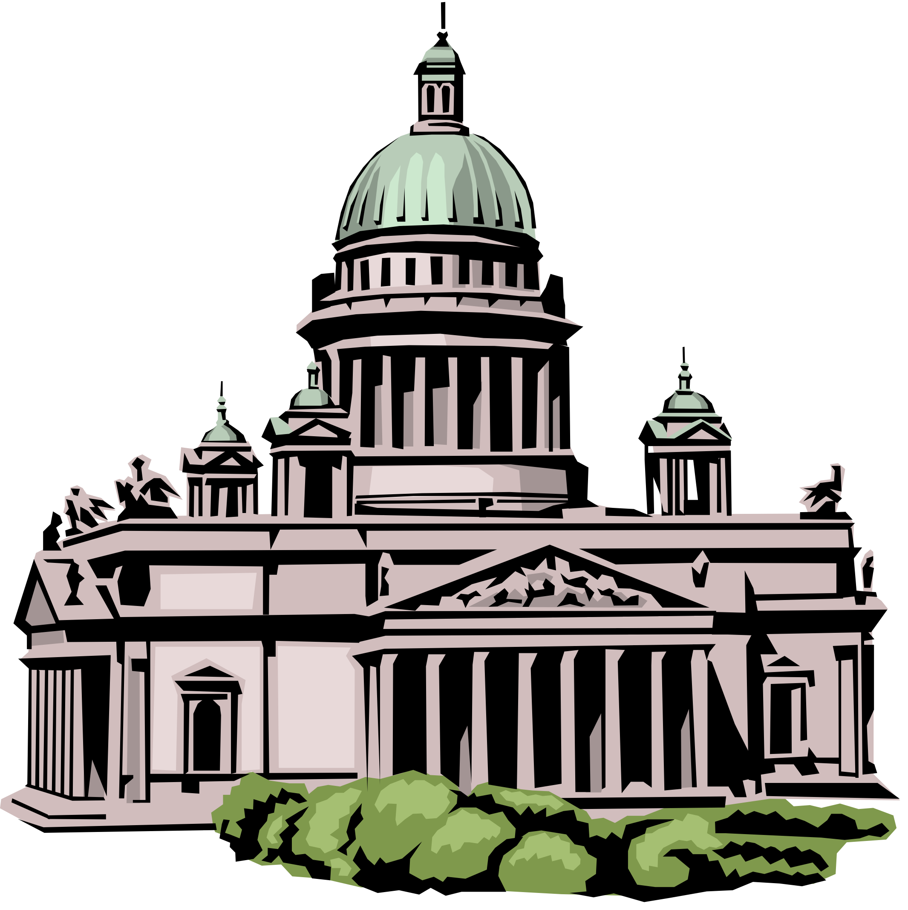
ETHICS REPORTER
March 2021

Kentucky Legislative Ethics Commission
22 Mill Creek Park, Frankfort, Kentucky 40601-9230
Phone: (502) 573-2863
http://klec.ky.gov
Legislative Ethics Commission enhances public’s access to bills lobbied in the Kentucky General Assembly

Starting in early March, the Kentucky Legislative Ethics Commission (KLEC) has made information on which bills legislative lobbying employers are promoting or opposing newly available to the public, via the LEC’s website.

While the Ethics Code, since its passage in 1993, has required entities with paid legislative agents to report the particular bills on which they are lobbying, this information has never been immediately accessible by the public on KLEC’s website.

By visiting KLEC’s website, citizens can now view the bills that particular groups are advocating for or against, giving the public a more accurate picture of lobbying activity in Kentucky.

“We hope this will make more information immediately available, so the public can better understand what legislation is being promoted or opposed by registered lobbying organizations,” said David Nicholas, who chairs the Ethics Commission.

KLEC’s Donnita Crittenden worked closely with the Commonwealth Office of Technology and LRC to create these public reports. The list is on LEC’s web site https://klec.ky.gov/Reports/Pages/Employers-and-Legislative-Agents.aspx under “Bills Lobbied”, by Current Year or Prior Year.

In addition to Nicholas, other members of the Legislative Ethics Commission are: Vice-Chair Michael Noftsger; former Representative Sheldon Baugh of Russellville; former Representative Pat Freibert of Lexington; Anthony Goetz of Nicholasville; Phil Huddleston of Frankfort; former Representative and Judge Tanya Pullin of South Shore; former Judge Paula Sherlock of Prospect; and former Judge Anthony Wilhoit of Versailles.
Lobbying spending in first two months of 2021 lags behind the 2019 record
January and February’s 2021 lobbying spending matched that of 2017’s pace, totaling $4.65 million. It fell short of the same period in 2019, which saw a record of $5.02 million.

621 legislative agents and 751 employers are currently registered to lobby the General Assembly.

2021's top spender thus far is Secure Democracy, which spent $91,240 in the last two months, the majority of that amount, $53,240, on a poll regarding elections legislation. The nonprofit group from Washington DC lobbied on HB 574, an omnibus elections bill, and HB 232 and SB 259.

Kentucky Chamber of Commerce was second, spending $90,093 on lobbying the General Assembly, followed by the rest of the top 5: Kentucky Education Association ($87,833); Kentucky Equine Education Alliance (KEEP) ($80,626); and American Civil Liberties Union of Kentucky ($70,126).
The rest of the top 20 spending entities are: Keeneland Association ($53,300); Altria Client Services LLC ($50,550); KY League of Cities ($41,829); KY Justice Association ($35,996); National Council of State Boards of Nursing ($35,685); Anthem Inc. and its Affiliates ($32,500); KY Hospital Association ($31,445); Greater Louisville, Inc. ($31,000); KY Retail Federation ($30,281); KY Association of School Administrators ($30,000); KY Medical Association ($29,409); LG&E and KU Energy LLC ($25,525); CSX Corporation ($25,500); Humana, Inc. ($24,649) and Heaven Hill Distilleries ($24,000).
Newly-registered lobbying employers & terminations

The following businesses and organizations recently registered to lobby in Kentucky: American Kratom Association; Brightview; Colonial Management Group, LP; Enhanced Capital; KY Billboard Coalition (JR Promotions & Huntington Billboards); KY Concrete Assn.; KY Cooperage Holding Company, LLC; Light River Technologies, Inc.; NetChoice; and Steve Wilson.

Several businesses and organizations terminated their registration, and are no longer lobbying the Kentucky General Assembly: Aurinia Pharma U.S., Inc.; Davis Fitness Development, Inc.; Larue County; and New Venture Fund.

Lobbying report deadlines and important reminder about reporting bill numbers

By Thursday, April 15, 2021 all lobbyists and employers are required to file Updated Registration Statements for the period of March 1 through March 31, 2021.

The easiest and quickest way for lobbyists and employers to file is to visit the Commission’s website: https://apps.klec.ky.gov/lec/onlinefiling.aspx .

Additionally, employers are reminded that they are required to report the specific bill numbers that they are lobbying on, as required by the Legislative Ethics Code. If your reports have not adequately reflected bill numbers in the past, please make every effort to reflect bill numbers in your updated registration statements going forward. As noted above, these are now newly available on the KLEC website for viewing at any time by the public.

Training for Lobbyists and Employers on video

The Legislative Ethics Commission has a training video from one of our in-person lobbyist and employer trainings on the LRC Capitol Connection YouTube page, for viewing at any time. The link is on our website, and also on the LRC Capitol Connection page at https://www.youtube.com/watch?v=ojKIWUNV8po&feature=youtu.be. The video walks through the online filing process in step-by-step detail. Please call us with any questions!

Overview of Legislative Ethics Code online

The Legislative Ethics Commission has a PowerPoint overview of the Legislative Ethics Code available for reference. The link is on our website, and also on the LRC Capitol Connection page at https://www.youtube.com/watch?v=I4FJvhrSoao. Feel free to watch!

Commission Office Procedures and COVID-19

Due to the current COVID-19 pandemic and following guidance from federal, state, and local officials, the Commission halted in-person services at its Frankfort office as of Tuesday, March 17, 2020. Email notifications were made to legislators and staff, as well as lobbyists, and employers, and a notice was placed on the Commission’s website and office door.

Legislators, staff, lobbyists, employers, and the public may continue to contact the office by phone at (502) 573-2863, by fax at (502) 573-2929, and via the email addresses listed on the staff page: https://klec.ky.gov/About-KLEC/Pages/Commission-Staff.aspx .

Additionally, new lines for direct access to Commission staff have been added. You may reach Laura Hendrix, Executive Director, at (502) 573-2910, and Emily Dennis, Counsel, at (502) 573-2911. You may still reach Donnita Crittenden and Lori Smither at the main Commission number (502) 573-2863.

If you need to send the Commission copies of paperwork, please scan and email it to the email addresses as listed on the staff page, or fax to the number above.

Continued thanks to the many lobbying entities who have honored our request to begin filing online, and those who have utilized this service for many years. If a lobbyist or employer is currently filing disclosures by paper and would like to file online, please email us and we can contact you with an ID and password.

If an entity needs to register as a lobbyist or employer, please email the required scanned paperwork to Donnita Crittenden or Lori Smither at the staff emails in the link above or fax them to (502) 573-2929. Blank forms may be found here https://klec.ky.gov/Forms/Pages/Get-Blank-Forms.aspx

All provisions of the Code of Legislative Ethics are in force during this time. If there is a need for an opinion about the application of the Code to any particular ethical issue that may arise, please continue to contact us and we will answer your questions.

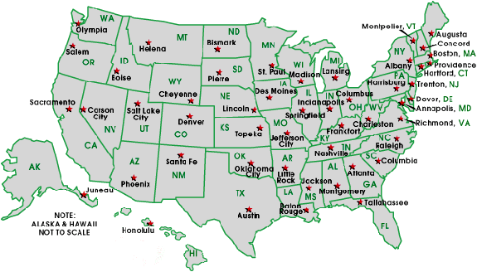
Ethics & Lobbying News from around the U.S.

Complaints filed about Maryland lawmaker who tuned into legislative meetings from the OR

MARYLAND– Baltimore Sun-- by Pamela Wood – March 24, 2021
Complaints have been filed with the Maryland Board of Physicians and the General Assembly’s ethics committee against a state lawmaker who twice joined legislative meetings by video from the operating room.

Del. Terri Hill a board-certified plastic surgeon, has acknowledged she twice logged in from the OR, once in February to testify on a bill and once for about an hour this month during a voting session.

She defended the practice as not much different from listening to music or a recorded book while in the OR. She said she had the patients’ permission and kept their safety and privacy at top of mind.

“There are no attention-to-duty issues and there’s no dereliction-of-duty issues,” she said Monday.

After The Baltimore Sun reported Tuesday on Hill’s operating room appearances, a Towson physician said he filed complaints with the Maryland Board of Physicians and the General Assembly’s Joint Committee on Legislative Ethics.

Hill declined Tuesday to comment. She represents parts of Baltimore and Howard counties.

The complainant, Dr. Alan L. Robin, said he was “outraged and appalled” when he learned of the doctor-delegate participating in video meetings from the operating room.

Robin retired from active practice two years ago as an ophthalmologist and specialist in glaucoma surgery. He remains a licensed physician and works as the executive vice president of the American Glaucoma Society.

Robin said that patients undergoing surgery need medical professionals who are entirely attuned to their needs. He questioned whether Hill could simultaneously give sufficient attention to medical duties and legislative duties.

“To me, personally, surgery is a very serious thing,” Robin said in an interview.

“This doctor should lose her license if the statements in the Baltimore Sun are correct,” Robin wrote in his complaint, which he shared with The Sun. “She is endangering a patient’s wellbeing by not focusing on the surgery and/or delaying a case by zooming with the legislature. This behavior is not appropriate and should not be allowed.”

Representatives of the state medical board could not be reached Tuesday for comment.

Robin said he also sent a complaint to the legislative ethics committee, a panel of delegates and senators that considers accusations of ethical violations by lawmakers. He received a reply from a committee attorney who wrote: “The committee will review this complaint at a future meeting.”

The ethics committee’s work is conducted confidentially during closed-door meetings and is only made public if the committee recommends disciplinary action against a lawmaker. The ethics committee does not have any meetings scheduled.

Due to the coronavirus pandemic, the General Assembly has conducted most of its committee hearings remotely and broadcast them on the legislature’s website and YouTube. Lawmakers use the Zoom videoconferencing platform to participate in hearings and voting sessions.

Many lawmakers have logged into video meetings from their Annapolis offices or Annapolis hotel rooms. At other times, lawmakers have appeared from home or from their cars.

One of Hill’s appearances from the operating room was brief, as she explained a bill she was sponsoring to the House of Delegates Environment and Transportation Committee. She appeared in a face mask, face shield and head covering.

The other episode came earlier this month, when Hill’s Zoom account was logged into a voting session of the House Health and Government Operations Committee for about an hour. The video shows a room with multiple sets of surgical lights and people moving about.

The patients weren’t visible in the videos.

SC AG Alan Wilson's office gives public corruption cases to Upstate prosecutor

SOUTH CAROLINA – The State (Columbia, SC) — by John Monk – March 18, 2021

State Attorney General Alan Wilson's office will give four high-profile cases involving alleged public corruption by three former state lawmakers and a political consultant to an Upstate elected prosecutor based in Spartanburg.

A letter sent Wednesday by one of Wilson's top deputies to Seventh Circuit Solicitor Barry Barnette says that Wilson has "removed himself personally from all involvement with these four defendants" and is giving them to Barnette.

"The Attorney General has delegated this office's responsibility in these cases to me," says the two-page letter, written by W. Jeffrey Young, chief deputy attorney general.

One case involves a man who was once one of Wilson's closest associates, Richard Quinn Sr.

Quinn, who in 2019 was indicted by a state grand jury on 11 counts of perjury and one count of obstruction of justice, is a legendary South Carolina political consultant who once worked closely with Wilson. For years, Quinn was at the center of a web of influence peddling and behind-the-scene payments to lawmakers in the S.C. General Assembly, according to a 2018 state grand jury report and court records.

A Wilson spokesman said Thursday that the attorney general and Quinn, who is in his mid-70s, have not spoken for several years.

The charges against Quinn and three former lawmakers that will now be handled by Barnette stem from special prosecutor David Pascoe's investigation, of more than five years, into State House corruption.

Pascoe's investigation, helped by the state grand jury and the State Law Enforcement Division, have over the years led to the convictions of five powerful GOP state lawmakers, including Quinn Sr.'s son, former Rep. Rick Quinn Jr.

In January, after a State Supreme Court decision in one of Pascoe's corruption cases placed limits on Pascoe's authority, Pascoe turned over his three remaining pending cases in his investigation to Wilson for disposal.

In its January decision, the Supreme Court also turned over a fourth Pascoe case to Wilson. That fourth case involved the high court's upholding of an 18-month prison sentence for perjury against former State Rep. Jim Harrison, a former chairman of the powerful House Judiciary Committee who was convicted of lying under oath as part of the broader public corruption investigation.

At the same time the Supreme Court upheld Harrison's perjury sentence, the high court overturned Harrison's conviction at the same trial on misconduct charges and gave that misconduct case to Wilson. Pascoe had exceeded his authority as special prosecutor for putting Harrison on trial for misconduct, the high court ruled.

Wilson should decide what to do with the overturned Harrison misconduct conviction and make that decision public, the high court said in January.

Pascoe then turned over his three remaining cases to Wilson, saying that way he would eliminate all possible confusion in the future.

The four cases that Barnette will now handle are:
— The perjury and obstruction of justice charges against Quinn Sr. The perjury charges allege Quinn repeatedly lied to the state grand jury in a confidential session about his involvement with various politicians including Wilson.
— A sentencing proceeding against former State Sen. John Courson, who pleaded guilty in 2018 to misconduct in connection with taking some $159,000 in payments from Quinn.
— Perjury and misconduct charges against former State Rep. Tracy Edge, indicted in 2017 by Pascoe's state grand jury.
— The misconduct charge against former State Rep. Harrison.

Over the years, Pascoe, State Law Enforcement Division investigators and the state grand jury rolled up a string of convictions, guilty pleas, resignations from public office and corporate integrity agreements and financial settlements with corporations who did business with Quinn's political consulting firm.

For years, Wilson had a special business and relationship with Quinn, likening him to "a second father," according to the 2018 state grand jury report delving into Quinn's dealings with members of the S.C. General Assembly and corporate and institutional organizations with business in the Legislature. Quinn was a top political consultant for numerous Republican S.C. politicians, including U.S. Sen. Lindsey Graham, of Seneca, and Gov. Henry McMaster.

In 2014, Wilson originally designated Pascoe as a special prosecutor to investigate former House Speaker Bobby Harrell, whose dealings were questioned in a 2013 SLED report. Harrell pleaded guilty to misconduct and resigned office in October 2014.

In 2015, Wilson's office said Pascoe could continue investigating two other lawmakers mentioned in that SLED report — Rep. Quinn Jr. and Rep. Jim Merrill. Both eventually pleaded guilty to misconduct and resigned from the General Assembly.

During the investigations into Quinn Jr. and Merrill, Pascoe and SLED uncovered evidence linking Courson and Harrison to non-public payments from Quinn Sr.'s firm.

Quinn Sr.'s alleged acts of perjury came when he testified before Pascoe's state grand jury about his dealings in the Legislature, according to records in the case.

The 2018 state grand jury that issued a report examining how Quinn Sr. did business in the General Assembly said that Wilson and Quinn were so close they "spoke nearly every day.”

Wilson was more loyal to Quinn and his family than to "the citizens of South Carolina, who he represents," the grand jurors said in their report, adding Wilson's "actions impeded this investigation.”

In recent years, the report said, Wilson had "reassured Mr. Quinn that everything would be fine and that he didn't believe the Quinns had done anything wrong.”

When the state grand jury report was released, Wilson criticized it, saying "the Pascoe report is riddled with already-disproven political innuendo and baseless conjecture. ... This is an entirely political smear less than a month from an election and it should be dismissed as just that.”

John Crangle, a lawyer who studies ethical issues in the General Assembly, said Thursday he had hoped the cases would be given to 5th Circuit Solicitor Byron Gibson, who is based in Columbia. Lawyers and defendants from three of the cases are in central South Carolina.

"They couldn't have moved these cases further from Columbia," Crangle said. "Spartanburg could not be more inconvenient.”

But Crangle said it was a positive sign that Wilson gave up the cases because the attorney general had conflicts of interest in the four cases. "There was no other option.”

Pascoe told The State on Thursday that he spoke with Barnette on Monday.

"I am confident that he will do an exceptional job in the prosecution of these cases and the investigation. He is a career prosecutor and he has a top-notch staff," Pascoe said.

The letter from the Attorney General's Office to Barnette pledges cooperation by Wilson's office in coordinating with the state grand jury and help with any travel and lodging costs.

The letter gives Barnette wide discretion in investigating and prosecuting with the Quinn Sr., Courson, Harrison and Edge cases.

But the letter from Wilson's office also said that if Barnette and his team turn up information that leads to new investigations concerning new defendants, "please advise this office on the matter so that we may decide how to proceed."

