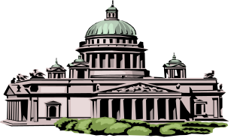
ETHICS REPORTER
May, 2018

Kentucky Legislative Ethics Commission
22 Mill Creek Park, Frankfort, Kentucky 40601-9230
Phone: (502) 573-2863
http://klec.ky.gov

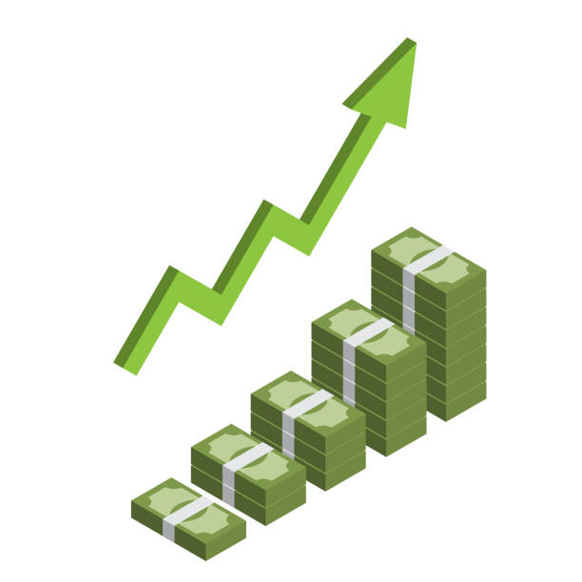
Lobbying spending hits all-time high in session

The final lobbying spending numbers for the 2018 General Assembly are in, and spending hit an all-time high of $10.67 million, putting Kentucky on track for a record-breaking year in which more than $22 million will be spent on lobbying.

The lobbying spending reports filed by a wide array of businesses and organizations give another clear picture of the increasing importance of public policy to the groups that lobby the General Assembly. This year’s spending total for the session is 11 percent higher than 2016 and 19 percent higher than 2017, and those were record years for even- and odd-year lobbying spending.

The 2018 surge in lobbying spending was led by several businesses which upped their lobbying efforts from prior sessions. For example, while fighting a proposed increase in the tobacco tax, Altria (Philip Morris), spent $379,760, which is more than twice as much as any other business spent, and about three times more than the average spent by Altria in each of the previous four legislative sessions.

Likewise, the second-leading spender, the Kentucky Chamber of Commerce, spent $187,103, or 29 percent more than the business group’s average in the past four sessions. Like the Chamber, the Foundation for a Healthy Kentucky supported a tobacco tax hike, and was the fifth-leading spender, at $110,766, which is 30 times more than the Foundation spent in all of 2017.

Third on the list is LG&E & KU Energy, which spent $126,858, mostly in support of HB 227, a bill to cut payments to utility customers who generate excess electricity via solar power, and sell it to utility companies. That four-month total is more than twice as much as LG&E has ever spent in a full 12-month period of lobbying.

In addition to LG&E and the Kentucky Chamber, other top-spending businesses listed HB 227 on their lobbying reports. Those include Kentucky Association of Electric Cooperatives ($79,376); Greater Louisville, Inc. ($66,849); Big Rivers Electric Corporation ($54,305); and Kentucky Coal Association ($50,954).

The KY Hospital Association finished in the top five at $111,696, which is 12.5 percent more than the average spent by the group in the last four sessions. Other top spenders include: 1-800 Contacts ($96,347); KY League of Cities ($77,203); Anthem, Inc. ($72,064); KY Education Association ($71,968); Baxter Healthcare ($70,000); KY Justice Association ($67,060); KY Medical Association ($65,308); KY Retail Federation ($62,535); KY Bankers Association ($60,728); Marsy’s Law for All ($54,240); U.S. Justice Action Network ($53,500); CSX ($52,864); KY Farm Bureau Federation ($52,574); KY Association of Healthcare Facilities ($51,707); and Pathfinder Capital ($50,000).
Lobbying terminations and registrations

Businesses and organizations which terminated lobbying registration after the end of the 2018 General Assembly are:

Advance America Cash Advance Centers, Inc.; American Progressive Bag Alliance; American Retirement Association; Americans United for Separation of Church & State; Crown Cork & Seal Co.; Hollenbach-Oakley, LLC; Oldham Reserve Partners, LLC; Opternative; Petersen International Underwriters; QC Holdings, Inc.; Simple Contacts; SpeedWash Car Wash - Fern Creek; Starr's Liquor; Thomas D. Clark Foundation, Inc.; and Warby Parker.

Newly registered employers are: Lyft, Inc. and Organization for International Investment.
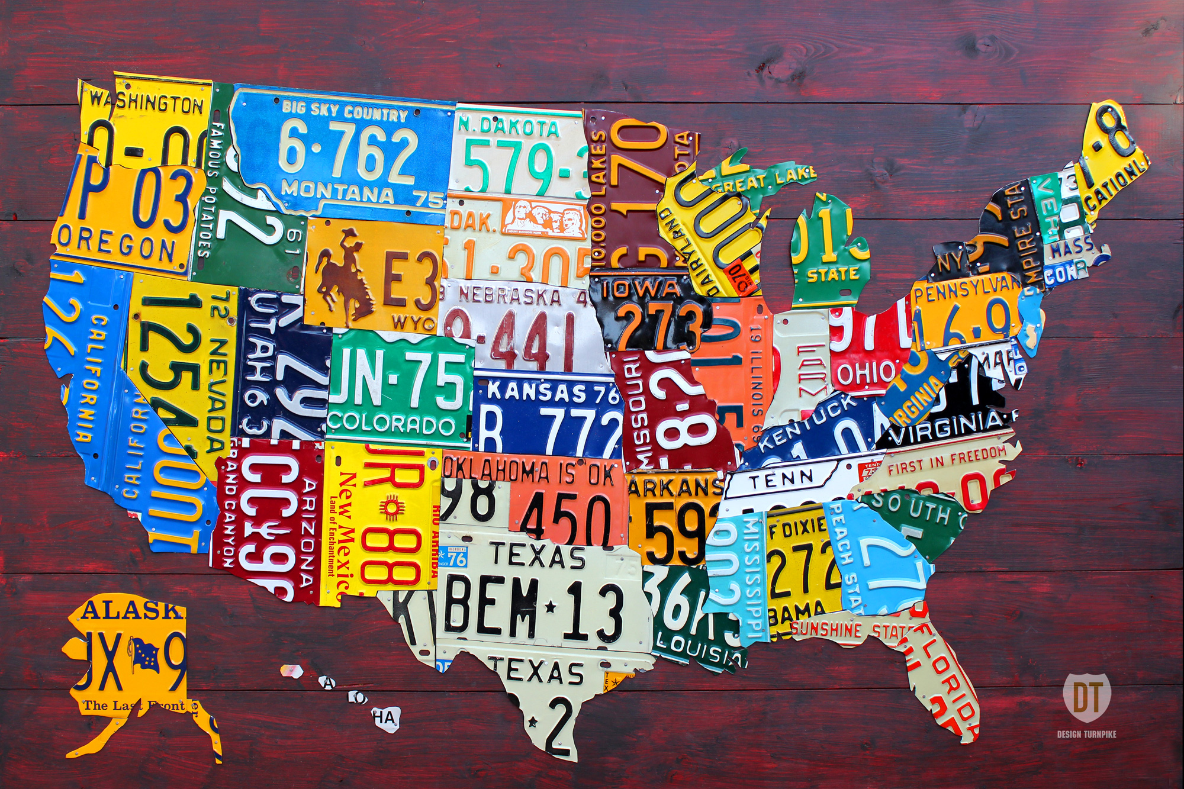
Ethics News from around the U.S.A.

Wilkins, former Arkansas legislator, pleads guilty to bribery
ARKANSAS – Arkansas Business -- by Jan Cottingham -- April 30, 2018

Henry "Hank" Wilkins IV of Pine Bluff, a former Arkansas legislator and the Jefferson County judge until his sudden resignation last month, pleaded guilty in federal court to conspiring to accept more than $80,000 in bribes.

Wilkins, who served as both a state senator and state representative, took the bribes in exchange for "influencing Arkansas state legislation and transactions," including steering about $245,000 in state funds to his co-conspirators, according to a press release from the U.S. Attorney's office in Little Rock.

Wilkins pleaded guilty to devising a scheme to disguise the bribes as donations to St. James United Methodist Church in Pine Bluff, where he was pastor.

"Public corruption destroys the trust that is necessary for our republic," U.S. Attorney Cody Hiland said in the release. "In this case, the citizens of Arkansas were betrayed by Mr. Wilkins, and elected officials who abuse their position for personal gain must be held accountable for that violation of the public trust."

Hiland announced Wilkins' guilty plea after a hearing before Chief U.S. District Judge Brian S. Miller. Wilkins pleaded guilty to one count of conspiracy to commit honest services fraud and bribery.

Wilkins, 64, announced his resignation on March 19, three days after federal prosecutors in Missouri said he had taken bribes from Rusty Cranford of Rogers while Wilkins was a state legislator. Wilkins represented State House District 17 from 1999-2001 and from 2011-15, and State Senate District 5 from 2001-11.
As part of his guilty plea, Wilkins admitted that from 2010 to 2014, while he was serving in the Arkansas Legislature, he accepted bribes from lobbyists and nonprofit organizations in the form of both cash and checks. This money was "funneled from lobbying firms to a discretionary fund held in St. James' name where Wilkins had access to the deposited funds," the U.S. Attorney's office said.

In exchange, Wilkins filed shell bills, sponsored bills, voted for specific legislation, and steered about $245,000 in General Improvement funds to bribe-giving entities.

Cranford was both an executive and lobbyist for Preferred Family Healthcare Inc. (PFH) of Kirkwood, Missouri, which operates nearly 50 mental health and behavioral clinics in Arkansas under the names Health Resources of Arkansas and Decision Point. PFH acquired the Arkansas operations in May 2015 when it acquired Alternative Opportunities Inc. of Springfield, Missouri, which used the name Dayspring for some of its clinics.

Federal prosecutors in Missouri have accused multiple PFH executives of embezzling money from the nonprofit, which is largely supported by Medicare and Medicaid. They have elicited guilty pleas from three of them — including former Arkansas State Rep. Eddie Cooper of Melbourne.

Cranford has been indicted in the case, accused of steering kickbacks to at least three Arkansas legislators: former Rep. Micah Neal of Springdale, who pleaded guilty to federal charges in January 2017; former state Sen. Jon Woods of Springdale, who is on trial for taking kickbacks; and Wilkins.

The charge against Wilkins carries a maximum penalty of not more than five years in prison, not more than a $250,000 fine and not more than three years of supervised release. Miller will sentence Wilkins at a later date.

Former state Sen. Jon Woods found guilty in federal corruption case
ARKANSAS – Arkansas Times -- by David Ramsey -- May 3, 2018

Former Arkansas State Senator Jon Woods was found guilty on 15 of 17 counts in his federal corruption trial.

Consultant Randell Shelton Jr., on trial on related charges, was found guilty on 12 of 15 counts. They face up to 20 years in prison on each charge of fraud and conspiracy to commit fraud; Woods was also found guilty on one count of money laundering, for which he would face a maximum of 10 years in prison.
Woods stood accused of participating in a kickback scheme in exchange for guiding state money to a small Christian college in Springdale, Ecclesia College, and to a nonprofit under the umbrella of Preferred Family Healthcare, a major provider of Medicaid-funded services in the state.

Former state Rep. Micah Neal pleaded guilty to being a co-conspirator in both schemes before the trial started and cooperated with the government. Oren Paris III, president of the college, pleaded guilty to being a co-conspirator in the Ecclesia scheme less than a week before the trial began, cooperating with the government.
Shelton Jr. stood accused of participating in the Ecclesia scheme, with the kickback payments disguised as payments to his consulting company.
The jurors heard testimony that legislators Woods and Neal directed $400,000 in public General Improvement Fund (GIF) money to Ecclesia in exchange for kickbacks. They also communicated by text message with their co-conspirators about directing additional GIF money to the college via other legislators, including identifying who would target which lawmaker and how much they would ask for.

None of the other legislators recruited for the GIF grab have been charged with a crime, but the efforts of Woods and Neal were quite successful. Between 2013 and March of 2015, the following lawmakers sent GIF money to Ecclesia: Sen. Bart Hester (Cave Springs) sent $60,000, Sen. Cecile Bledsoe (Rogers) $60,000, former state Rep. Randy Alexander (Rogers) $26,500, Rep. Stephen Meeks (Greenbrier) sent $25,000, Rep. Charlie Collins (Fayetteville) sent $14,000, Rep. Jim Dotson (Bentonville) sent $13,500, Rep. Bob Ballinger sent (Hindsville) $8,500, and Rep. Debra Hobbs (Rogers) sent $10,000.
Yet more GIF money was sent to the college by multiple former and current legislators later in 2015.
According to testimony from Neal, the GIF system was a "slush fund." Hester also testified for the prosecution, and told jurors that legislators had total control of sending their allotted amounts of GIF money to pet projects.
According to the indictment, Paris disguised the kickbacks as payments to Shelton's consulting company. Neal testified that Shelton delivered two envelopes stuffed with $100 bills, totaling $18,000, to him behind his family-owned restaurant in Springdale, Neal's Cafe. The total amount of the kickback payment to Woods was not specified by the government, but the indictment stated that it involved both cash and a $40,000 wire transfer.
The jury also heard evidence and testimony about another alleged kickback scheme, this one involving corporate entities associated with Preferred Family Healthcare, a Missouri-based nonprofit with a large footprint in the state's health care system, which has received (and continues to receive) tens of millions of dollars from the state in Medicaid contracts, general revenue funding, and GIF largesse.
Woods directed $275,000 to an entity under the PFH umbrella and Neal directed $125,000. Little Rock lobbyist Rusty Cranford, then a PFH executive, signed the application for the grants and accepted the funds, which he then deposited into the account of yet another corporate identity, AmeriWorks, a new nonprofit that he incorporated the day after accepting the grants.

The jury heard evidence that Cranford paid Sen. Woods an unknown amount of money in kickbacks the next month; Woods paid Rep. Neal $20,000 on Cranford's behalf; and AmeriWorks sent Cranford's lobbying firm a check for $16,500. Cranford has also been indicted on unrelated federal charges in Missouri for a separate kickback scheme involving PFH.
In addition to the kickbacks, the jury heard testimony that Cranford helped secure an overpaid job for Woods' fiancée.

Four months after the $400,000 windfall, Cranford landed her a job at Dayspring, one of the nonprofits under the PFH umbrella. She was hired in February as an on-the-job trainer for Dayspring at $70,000 a year, helping clients at the substance abuse treatment center with employment. She also received $300 per month in mileage allowance and cell phone reimbursement.

In email discussions with Cranford about paying her an exorbitant salary, PFH executive Tom Goss stated, "Senator is taken care of. He is a new bubba for our team."
In addition to the GIF giveaways, the jury heard testimony that Sen. Woods and Rep. Neal tried to send $4.7 million in state grants and other public no-interest loans to move a thermostat manufacturer from Springfield, Mo., to northwest Arkansas. Woods was tapped to gather support for the deal in the Senate and Neal in the House, according to evidence presented by the government (the deal ultimately never materialized).
Justice Department attorney Sean Mulryne told the jury, "Mr. Woods used his office as senator as a legislative ATM." Woods' attorney argued to the jury that it was all legal and routine legislative activity and "there's sunshine on everything. ... It's all open. There is nothing behind the scenes."
Woods and Neal are two of the five former lawmakers who have faced federal charges related to improper use of GIF money.
Former state Rep. Hank Wilkins pleaded guilty to accepting kickbacks. According to his plea agreement and statements in previous court proceedings, Cranford appears to be the lobbyist involved in arranging those bribes.
Former state Rep. Eddie Cooper pleaded guilty to an embezzlement and kickback scheme involving Cranford and PFH.
Former state Rep. Jake Files pleaded guilty to charges of wire fraud, bank fraud and money laundering. He admitted to misdirecting more than $25,000 in taxpayer money for a sports complex his construction company was supposed to build, and pocketing GIF funds for personal purposes. He faces sentencing in federal court this summer.

Former Maryland Delegate Will Campos sentenced in bribery scheme
MARYLAND – Washington Post – by Lynh Bui – May 16, 2018

A former Maryland state delegate and ex-Prince George’s County Council member was sentenced to four and a half years in prison in a bribery case prosecutors said involved “the use of taxpayer money as if it were a literal slush fund.”

William A. Campos, 43, of Hyattsville, pleaded guilty to accepting roughly $50,000 in bribes and kickbacks in exchange for official favors and help obtaining government money.

Most of the bribery and conspiracy scheme involved Campos’s misusing more than $300,000 in county money, including grants intended to help nonprofit organizations, federal prosecutors said. Campos accepted personal payments between 2007 and 2014 from those who wanted access to the funds.
At his sentencing hearing, Campos apologized and said he was “young and stupid.” “I don’t claim to be anything other than a human who makes mistakes,” Campos said.

Campos took bribes over seven years on at least seven different occasions, according to prosecutors. In one instance, Campos accepted $3,000 in the bathroom of a College Park restaurant after he agreed to help a business move to the county and also promised to direct $10,000 in government money to a nonprofit that the briber could control. The person making the payoff was a government informant.

Campos’s case was part of a larger federal investigation into a pay-to-play scheme involving state lawmakers who sold their votes on legislation to expand liquor store sales in Prince George’s County.

In March, a jury found former Maryland State Delegate Michael L. Vaughn guilty of conspiracy and bribery for accepting cash from liquor store owners in exchange for votes.

Federal prosecutors have not detailed how Campos is involved with the liquor board scandal. But court documents describing an individual who agreed to cooperate with federal investigators in the liquor board probe align with details in Campos’s plea agreement.

In second trial, former speaker of N.Y. Assembly convicted of corruption
NEW YORK – New York Times – by Benjamin Weiser -- May 11, 2018

Sheldon Silver, the former powerful Speaker of the New York State Assembly, was found guilty of federal corruption charges, less than a year after his first conviction on the same charges was thrown out.

Silver was convicted in 2015 on charges related to nearly $4 million he obtained in illicit payments in return for taking actions that benefited a cancer researcher at Columbia University and two real estate developers in New York.

The case was among a number of political corruption cases that were overturned after the U.S. Supreme Court in 2016 narrowed the activity that could constitute corruption. In a ruling that reversed the conviction of Bob McDonnell, a former governor of Virginia, the court found that such activity must involve concrete and formal government decisions or actions, and not mere political courtesies like setting up a meeting.

Silver's retrial was widely watched as a test of the government's ability to prosecute official corruption under the narrower definition.

The retrial in U.S. District Court for the Southern District in Manhattan seemed to move at double speed: Instead of stretching over one month, as the first trial had, the second trial was completed in two weeks, as prosecutors quickly made their case that Silver, 74, had obtained the illicit payments. In return, prosecutors said, Silver took a series of official actions that benefited a cancer researcher at Columbia University and two real estate developers in New York.

"Sheldon Silver repeatedly used his enormous public power for his own enormous private gain," a prosecutor, Tatiana R. Martins, told the jury in a closing statement.
Silver spent more than two decades as the Assembly speaker, and along with Gov. Andrew M. Cuomo and Dean G. Skelos, the former State Senate majority leader, became known as one of New York's "three men in a room" who controlled decision making in Albany.

Both Silver and Skelos forfeited their seats in late 2015 after each was convicted in separate corruption trials. But both men's convictions were overturned last year. Skelos is to be retried in June.

In reflecting on Silver's conviction, Geoffrey S. Berman, the U.S. Attorney for the Southern District of New York, cited the "importance of pursuing cases against corrupt politicians, no matter the difficulty."

As in Silver's first trial, the prosecutors presented evidence that he had arranged to have the state Health Department award two grants totaling $500,000 to Robert N. Taub, who ran a clinic dedicated to mesothelioma research.

In return, Taub, over about a decade, referred nearly 50 cancer patients with legal claims to the law firm Weitz & Luxenberg, which gave Silver a portion of its fees. Taub, testifying last week, recalled that a mutual friend had told him that "Shelly wants cases."

"Silver knew that Dr. Taub was sitting on something worth a lot of money, an active medical practice full of mesothelioma patients with valuable legal claims," Martins told the jury.

In the second scheme, prosecutors showed Silver had the two developers, Glenwood Management and the Witkoff Group, move certain tax business to a law firm, Goldberg & Iryami, which also kicked back to Silver a portion of its fees.

FBI raids home of former Ohio House Speaker Rosenberger
OHIO – Dayton Daily News – by Laura A. Bischoff – May 23, 2018

Federal agents searched former Ohio House Speaker Cliff Rosenberger's southwest Ohio home and a nearby storage unit, apparently part of an investigation into the money behind his international travel and lavish lifestyle while serving as one of the state's most powerful politicians.
“We are conducting law enforcement activities in those areas,” said FBI spokesman Todd Lindgren. He declined further comment.
Agents dressed in khakis and navy blue polo shirts and wearing gloves and holstered weapons could be seen walking in and out of Rosenberger’s house on State Route 350 in Clarksville, which owned by his parents, and 761 South Nelson in Wilmington. The Wilmington address houses businesses, including the Wilmington News Journal.
Rosenberger’s criminal defense attorney, David Axelrod, said in a written statement: “Speaker Rosenberger and I are cooperating with authorities. We previously offered to provide the material sought today by warrant, and today voluntarily provided additional material not covered by the warrant. Speaker Rosenberger has also complied with a requirement to file legal disclosure forms regarding gifts, meals and travel. Speaker Rosenberger has acted lawfully and ethically and looks forward to a positive resolution of the matter.”
Rosenberger resigned in April after disclosing that he hired Axelrod to handle an FBI inquiry. He said all his actions have been lawful and ethical. The FBI is reportedly looking into a four-day trip Rosenberger took to London in August 2017 that was partially underwritten by payday lending interests. This newspaper found that Rosenberger made three international trips — China, London and Normandy — with payday lenders as well.
House Bill 123, which would institute the most sweeping reforms to payday lending in a decade, stalled in the House under Rosenberger’s leadership. While it gained momentum after Rosenberger’s resignation, the bill is now in limbo because of an internal fight over who will replace Rosenberger as speaker for the remaining seven months of the two-year legislative session.
Speaker Pro Tempore Kirk Schuring, Canton, a trusted lieutenant of Rosenberger, said he was unaware of the FBI raids and that agents were not searching state properties.
A source who works for the Ohio House said Rosenberger’s campaign treasurer, Bret Dixon, supervised the removal of items from Rosenberger’s state offices and conference room on May 11. Dixon is a developer and former economic development director for Clinton County.
In his 2017 financial disclosure statement, Rosenberger reported taking more than $43,000 in free travel and receiving free meals and drinks from half a dozen sources. The disclosure was made to the Joint Legislative Ethics Committee — a body Rosenberger used to lead as speaker.
In the filing, Rosenberger also noted that he owed at least $1,000 to five entities, including Northbank 503 LLC, which is controlled by Virginia Ragan, a wealthy heiress and political donor. Northbank owns a luxury condo in downtown Columbus that Ragan allowed Rosenberger to rent. Neither has disclosed how much rent he was charged for use of the 2,237-square-foot condo overlooking the Scioto River. Ragan bought the property in March 2014 for $660,000.
Rosenberger, who is single and has no children, does not own real estate and stays at his parents’ house on State Route 350 in Clarksville.
Bills target corrupt SC lawmakers, lobbyists who use their posts for profit
SOUTH CAROLINA – The State – by John Monk -- May 2, 2018

Columbia -- Anti-racketeering proposals before the S.C. General Assembly would target corrupt lawmakers and lobbyists who illegally buy and sell influence, supporters said.

"This building is rampant with corruption," Lt. Gov. Kevin Bryant, Anderson, said at the State House, joined by the anti-racketeering bill's sponsors.

One floor up, in the great lobby that separates the S.C. House and state Senate, dozens of lobbyists, and current and former lawmakers milled about talking shop.

However, Bryant said the S.C. Anti-Racketeering Act would target that business as usual, giving prosecutors a law to use to target conspiracies to buy and sell influence.

The proposed law, introduced as separate House and Senate bills last week, has no chance of passing this year.
If the proposal becomes law, it will need to be accompanied by substantial funding to pay for racketeering investigations, which are expensive — costing hundreds of thousands of dollars, Bryant and state Sen. Tom Davis, Beaufort, acknowledged.

Bryant, who is running for governor, specifically cited the ongoing State House corruption investigation, being conducted by state special prosecutor David Pascoe, as the reason he is supporting the anti-racketeering bill.

"There's a godfather running this government, and his name is Richard Quinn," Bryant told reporters, mentioning the political godfather who has been a focal point of Pascoe's investigation.

Had the Anti-Racketeering Act been in place, Pascoe's investigation, now in its fourth year, would have gone faster or "would not have taken place," Bryant said.

Quinn, a longtime, Columbia public relations consultant and political strategist, has denied any wrongdoing. However, last year, his public relations firm, Richard Quinn & Associates, entered a guilty plea to failing to register as a lobbyist and paid a $3,000 fine.

Quinn also reportedly testified before the state grand jury recently. His testimony, made in secret, is not publicly known.

At one time, Quinn's firm represented a host of South Carolina's most powerful institutions and politicians — from SCANA Corp., a $5 billion energy company, to BlueCross, to the University of South Carolina, to Gov. Henry McMaster, to S.C. Attorney General Alan Wilson, to U.S. Sen. Lindsey Graham.

Quinn's son, former state Rep. Rick Quinn, Lexington, pleaded guilty to misdemeanor misconduct in office, resigned his office, paid a $1,000 fine and agreed to do 500 hours of community service.

In courtroom statements and filings, Pascoe has said the Quinns were at the center of a wide-ranging, hidden, moneymaking scheme to peddle influence at the State House.

On June 4, longtime RQ&A client state Sen. John Courson, Richland, is scheduled to go on trial on charges of receiving kickbacks from Richard Quinn's firm. Two other former lawmakers, state Reps. Jim Harrison of Columbia and Tracy Edge of Myrtle Beach, also face charges of secretly being on Richard Quinn's payroll while they were lawmakers.

Robin Vos, other Wisconsin lawmakers billed taxpayers $4,300 for one-day trip to Ohio
WISCONSIN -- Milwaukee Journal Sentinel – by Patrick Marley -- May 14, 2018

Madison – Wisconsin Assembly Speaker Robin Vos and two of his colleagues billed taxpayers $4,300 last year to take a state plane to Ohio so they could participate in a news conference with lawmakers from the Buckeye State.

Vos (Rochester) and Wisconsin Reps. Mike Rohrkaste (Neenah) and Tyler Vorpagel (Plymouth) flew to Columbus in February 2017 to join their Ohio counterparts to discuss the importance of giving states more power.
The Wisconsin lawmakers brought five staff members with them and returned the same day, according to a summary of the trip recently released under Wisconsin's open records law.

Details of the trip come to light as Vos faces scrutiny over his travel.

Vos received about $13,000 in travel and perks from outside groups last year, bringing his four-year total to about $57,000 for jaunts to England, France and elsewhere.

For the England trip, sponsors including lobbyists were charged $25,000 apiece to join the trip with Vos and lawmakers from other states, according to public records.

The trip to Ohio was different — that one was funded by Wisconsin taxpayers, not organizations that say they provide free travel to state lawmakers for educational purposes.

Gov. Scott Walker and his predecessors have long used state planes to travel Wisconsin to promote their agendas, but it is rare for state lawmakers to use state planes. In the past two years, Vos has done it only one other time, when he joined Walker this January to fly around Wisconsin to promote their plans to overhaul welfare programs.

On the trip to Ohio, Vos partnered with then-Ohio House Speaker Cliff Rosenberger to show support for having the federal government turn over more duties to the state.

“This is a little unconventional in that we have never had a press conference with another state before," Rosenberger said at the opening of the news conference.

Vos said at the news conference he hoped to get "really good ideas" he could take back to Wisconsin.

“Legislators discussed the important issues facing each of our states, including the opioid epidemic and the growing prevalence of Alzheimer’s and dementia," Vos spokeswoman Kit Beyer said in a statement. "In addition, lawmakers began working on a coordinated effort to promote federalism in order to have Washington give states more power to innovate and reform.”

Rosenberger's travel is the subject of an FBI investigation. Rosenberger resigned last month because of the investigation, but said he is confident he will be cleared.

"Taxpayers paid for Robin Vos to take a state a plane so he could meet with a guy who resigned from office because he's under investigation with the FBI," said a statement from Joanna Beilman-Dulin, research director for One Wisconsin Now. "We need a full accounting of every single person that taxpayers financed Vos and his entourage to fly to Ohio and meet with."

Vos last year went on a trip to France bankrolled by the nonpartisan National Conference of State Legislatures just before he got married in Italy. Rosenberger served as his best man.

Wisconsin's ethics laws generally prohibit legislators from accepting valuable gifts but do allow them to accept travel expenses to go to conferences about official business, according to the state Ethics Commission.

